PIHAK BERKUASA PENERBANGAN AWAM MALAYSIA
(CIVIL AVIATION AUTHORITY OF MALAYSIA)

GOVERNMENT AGENCIES TO CONDUCT ADHOC UAS OPERATIONS (GAO) APPLICATION FORM

This Government Agencies to Conduct AdHoc UAS Operations (GAO) application form is designed solely for the use of Government Agencies, Local Authorities, Law Enforcement Agencies and/or Local Safety Entities to operate Unmanned Aircraft System (UAS/Drone) for the purpose of law enforcement, surveillance and/or other related activity of public interest protection in Visual Line of Sight (VLOS) and/or Extended Visual Line of Sight (EVLOS) only.

SECTION I : PERSONAL PARTICULARS OF THE ACCOUNTABLE PERSON
Full Name: | :
Passport/NRIC | :
Company / Organisation | :
Company Registration No. | :
Business Address | :
Office Telephone No. | :
Mobile Telephone No. | :
Fax No. | :
Email | :

The Accountable Manager (AM) usually termed as Director is the personnel who is accountable for safety and corporate compliance. This person shall provide the necessary resources to ensure all operations and maintenance can be safely conducted to meet the obligations, goals and objectives including finance and human resources. The AM is accountable to ensure that any operation conducted is within the compliance of the legislation - Malaysian Civil Aviation Regulation 2016 and any other agencies pertaining UAS activity.

SECTION II : REMOTE PILOT DETAILS
Please add on to the list if there are any additional pilots
No. | Name | Passport/NRIC | Nationality | Brand/Model of UAS | Details of training/course(s) attended | Details
 |  |  |  |  |  | Total Hours
 |  |  |  |  |  | Last Date Flown
 |  |  |  |  |  | Total Hours
 |  |  |  |  |  | Last Date Flown
 |  |  |  |  |  | Total Hours
 |  |  |  |  |  | Last Date Flown
 |  |  |  |  |  | Total Hours
 |  |  |  |  |  | Last Date Flown
 |  |  |  |  |  | Total Hours
 |  |  |  |  |  | Last Date Flown
 |  |  |  |  |  | Total Hours
 |  |  |  |  |  | Last Date Flown

SECTION III : UNMANNED AIRCRAFT SYSTEM SPECIFICATIONS
Please add on to the list for each model if more than one model of unmanned aircraft is being used.

Brand/model of Unmanned Aircraft (UA) | :
Type of UAS (Quadcopter, Hexacopter, VTOL, Fixed wing, etc.) | :
UA Serial Number | :
SIRIM UAS Certification.  1. Company:  a. MCMC Label Serial Number;  b. Type Approval / Certificate of Conformity (Serial Number); or  c. Special Approval Certificate (Serial Number).  2. Individual:  a. MCMC Label Serial Number; or  b. Special Approval Clearance Letter (CL Number). | :
Weight (kg) | :
Length (m) | :
Wingspan (m) | :
Power source | :
Maximum flight duration (minutes) | :
Maximum speed (m/s) | :
Maximum height capable (m) | :
Maximum distance capable (m) | :
List the brands and models of all wireless transmitting devices used, including radio controller, video, etc | :
List the frequencies used by each model | :
List the output power of each model | :
TOTAL NUMBERS OF UNMANNED AIRCRAFT USED:

SECTION IV - PERSONNEL LIST FOR THE UAS OPERATION
The Accountable Manager shall submit the details of all personnel involved for the UAS operation in form below:

No. | Name | IC Number | Mobile Number | Designation

SECTION V: DECLARATION STATEMENT

CAAM will not take any responsibility and is absolved in any liability for any damage(s) in relations to the operation.
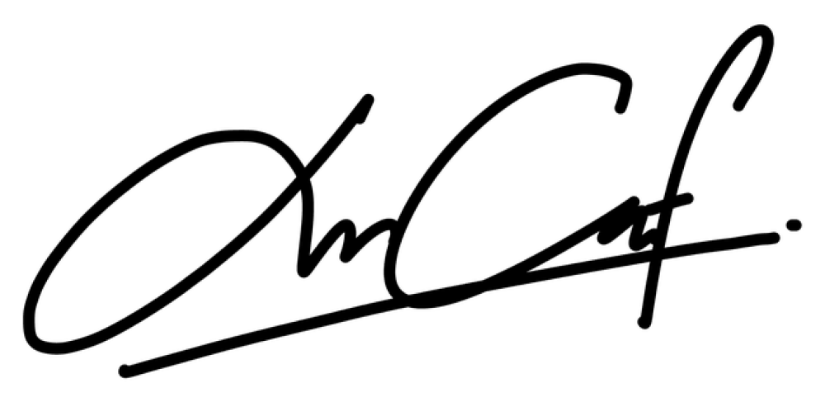
I, (Accountable Person) (I/C Number) from (organisation) agrees to take full accountability and responsibility of the operations.

.......................................................
Name:
Date:

DOCUMENT SUBMISSIONS CHECKLIST

NO. | DOCUMENTS | YES | NO | REMARKS
1 | PERSONAL PARTICULARS OF THE ACCOUNTABLE PERSON
 | a. Accountable Person Identification Card
2 | REMOTE PILOT DETAILS
i. | Competency Evidence; and
ii. | Remote Pilot Identification Card
3 | UNMANNED AIRCRAFT SYSTEM SPECIFICATIONS
i. | SIRIM Approval
ii. | MCMC Approval / Certificate¹.
iii. | UAS User Manual / Specifications Brochure.
4 | PERSONNEL LIST FOR THE UAS OPERATION
5 | STANDARD OPERATING PROCEDURES (SOP) DOCUMENT
6 | EMERGENCY RESPONSE PLAN & RECOVERY (ERP) DOCUMENT
7 | TRAINING MODULE
8 | WEEKLY OPERATION REPORT
i. | Sample Format
9 | INCIDENT REPORT
i. | Sample Format
10 | OTHER AGENCIES APPROVAL
i. | Chief Government Security Office - CGSO (if applicable)
ii. | Jabatan Ukur dan Pemetaan Malaysia (JUPEM)²
iii. | Chief Minister Office of Sarawak / Sabah (if applicable)
iv. | Jabatan Tanah dan Ukur Sarawak / Sabah (if applicable)
11 | OTHERS
i. | Declaration Statement
ii. | Official Application Letter

¹ If UAS requires an Apparatus Assignment. (UAS using Class Assignment – 433 - 435 MHz, 2400 - 2500MHz, 5725 - 5875 MHz falls into Class Assignment and does not required an Apparatus Assignment).
² If UAS carries camera as payload.

