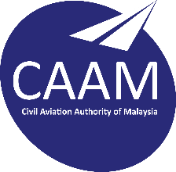 | CIVIL AVIATION AUTHORITY  MALAYSIA
REPLACEMENT CERTIFICATE OF REGISTRATION OF AIRCRAFT
(Civil Aviation Regulations 2016)

1. Malaysian Registration Mark |  |  |  |  |  |  | 9M -
2. a. Manufacturer of aircraft |  |  |  |  | a.
b. Designation of aircraft |  |  |  |  | b.
c. Manufacturer Serial Number |  |  |  |  | c.
3. Name of owner

4. Address of owner

5. Replacement of the certificate due to : -
( mark √ where applicable )

Lost
Damaged that particulars are no longer legible
- Fee on application for replacement of certificate is RM 250.00
Date .......................................... Signature .........................................
(authorised signatory if registered to a company)

Name......................................... Position held:....................................

FOR OFFICIAL USE ONLY
Fee |  | YES / NO |  |  |  | receipt no.
Amount received |  | RM |  |  |  | date of payment
Remarks |  |  |  |  |  | signature

Note:

- Regulation 191 of the Civil Aviation Regulations 2016 requires that the registered owner shall immediately notify to the Authority of any lost or damaged of certificate.
- This form should be used by the registered owner to notify Authority of any lost or damaged of certificate.

