PIHAK BERKUASA PENERBANGAN AWAM MALAYSIA
(CIVIL AVIATION AUTHORITY OF MALAYSIA)

APPLICATION FOR UNMANNED AIRCRAFT SYSTEM (UAS) / DRONE
(Regulation 140/141/142/143/144/189 – MCAR 2016)

This form is to be filled up by the person having management of the UA, and not another person who may, for example, have contracted with the operator to have work done. Application form and supporting documents needs to be submitted at least 14 days before the proposed activity date to drone.atf@caam.gov.my to avoid any delay.
SECTION I : PERSONAL PARTICULARS OF THE ACCOUNTABLE MANAGER
Full Name
Passport/NRIC
Name of Company
Company Registration Number
Postal Address
Telephone / Mobile No
Fax Number
Email

The Accountable Manager (AM) usually termed as CEO or Director is the personnel who is accountable for safety and corporate compliance. This person shall provide the necessary resources to ensure all operations and maintenance can be safely conducted to meet the obligations, goals and objectives including finance and human resources. The AM is accountable to ensure that any operation conducted is within the compliance of the legislation - Malaysian Civil Aviation Regulation 2016 and any other State or Local Law pertaining UAS activity. For individual applicants, the applicant shall be the Accountable Manager.

SECTION II : REMOTE PILOT DETAILS
Please add on to the list if there are any additional pilots
No. | Name | Passport/NRIC | Nationality | Brand/Model of UAS | Details of training/course(s) attended | Details
 |  |  |  |  |  | Total Hours
 |  |  |  |  |  | Last Date Flown
 |  |  |  |  |  | Total Hours
 |  |  |  |  |  | Last Date Flown
 |  |  |  |  |  | Total Hours
 |  |  |  |  |  | Last Date Flown
 |  |  |  |  |  | Total Hours
 |  |  |  |  |  | Last Date Flown
 |  |  |  |  |  | Total Hours
 |  |  |  |  |  | Last Date Flown
 |  |  |  |  |  | Total Hours
 |  |  |  |  |  | Last Date Flown

SECTION III : UNMANNED AIRCRAFT SYSTEM SPECIFICATIONS
Please add on to the list for each model if more than one model of UAS being used.

Brand/model of Unmanned Aircraft (UA) | :
Type of UAS (Quadcopter, Hexacopter, VTOL, Fixed wing, etc.) | :
UA Serial Number | :
SIRIM UAS Certification.  1. Company:  a. MCMC Label Serial Number;  b. Type Approval / Certificate of Conformity (Serial Number); or  c. Special Approval Certificate (Serial Number).  2. Individual:  a. MCMC Label Serial Number; or  b. Special Approval Clearance Letter (CL Number). | :
Weight (kg)¹ | :
Length (m) | :
Wingspan (m) | :
Power source | :
Maximum flight duration (minutes) | :
Maximum speed (m/s) | :
Maximum height capable (m) | :
Maximum distance capable (m) | :
List the brands and models of all wireless transmitting devices used, including radio controller, video, etc | :
List the frequencies used by each model | :
List the output power of each model | :
TOTAL NUMBERS OF UNMANNED AIRCRAFT USED: | :

¹UAS that has a mass of 20 kilogrammes and more without its fuel but including any articles or equipment installed in or attached to the aircraft requires an airworthiness assessment.
SECTION IV : RISK ASSESSMENT
Risk Assessment identified by the company in terms of operations, UAS and area of operations. It is also required for the company to include adequate risk mitigation measures to reduce the risk of transmission of COVID-19 in accordance to the requirements set by Ministry of Health (MoH) and National Security Council (NSC).
Please add on to the list for each operation if more than one operation is intended.

Location: |  |  |  | Blocked Flight Date / Time:  (For NOTAM Purposes)  Example:  From 01/01/2020 (0900 hours) to  14/01/2020 (1700 hours)  Specific Flight Activity Date / Time:  Example:  Day 1 (Date / Time):  01/01/2020 (0900 – 1700 hours)  Day 2 (Date / Time):  02/01/2020 (0900 – 1200 hours)  Flight Duration per activity (minutes): |  |  | Job / Task Name (Descriptions):
Job / Task Category:  Example:  (Aerial Surveillance / Mapping / Inspection / Videography / Photography / Spraying / Demonstration / Recreational etc.) |  |  |  | Operation Type: (e.g. VLOS, EVLOS) |  |  | Maximum Height of operations (meters):
Section 1: Risk Assessment |  |  |  |  |  |  | Revision:
Risk No. | Phase(s) of Flight | Hazards (Potential Incident) | Consequence(s) |  | Causal Factor | Existing Control Description and Adequacy (only controls that are currently in place) |  | Additional Risk Treatment Strategies (to be implemented to reduce the risk)

SECTION V : FLIGHT PLANNING OF OPERATION AREA
Please add on to the list for each area of operation if more than one area of operation is intended.

Flight Planning for UAS Operation
Overview
There is a total of 3 parts in preparing the flight planning for UAS operation. Please complete all relevant sections.
PART A - Illustration of the entire activity area.
The Accountable Manager shall submit the entire activity area using a map application (e.g. Google Map etc.) with annotation of take-off / landing site.
The entire operating zone has to be marked and its GPS co-ordinates (4 corners) taken as suggested in the list below:
Activity zone (Green Zone): Activity area for all intended RPA flight-phases (Take-Off, Mid-Flight, Approach and Landing).
Geo-fencing zone (Yellow Zone): If the RPA strays from formation/flight path and encounters this boundary, flight control system instructs the RPA to return to home (fixed wing or multi-rotors) or hover in stationary (multi-rotors). Remote Pilot shall assume manual control and bring the RPA back to safety.
Risk zone (Red Zone): In rare case of malfunction or unexpected weather, if the RPA encounters this boundary, flight control system instructs the RPA to land or cut-off power to motor immediately. This is a safety measure (failsafe) to prevent fly-away or further motorized travel of the RPA.
Boundary zone (Blue Zone): This area shall be monitored by visual observers for safe operations during take-off, mid-flight, approach and landing flight phases. This area acts as a worst-case fall zone in case of UAS entering Risk Zone due to rare malfunction.

Example: Flight Operations Airspace Overview for LICC carpark Airfield and LICC observation deck area
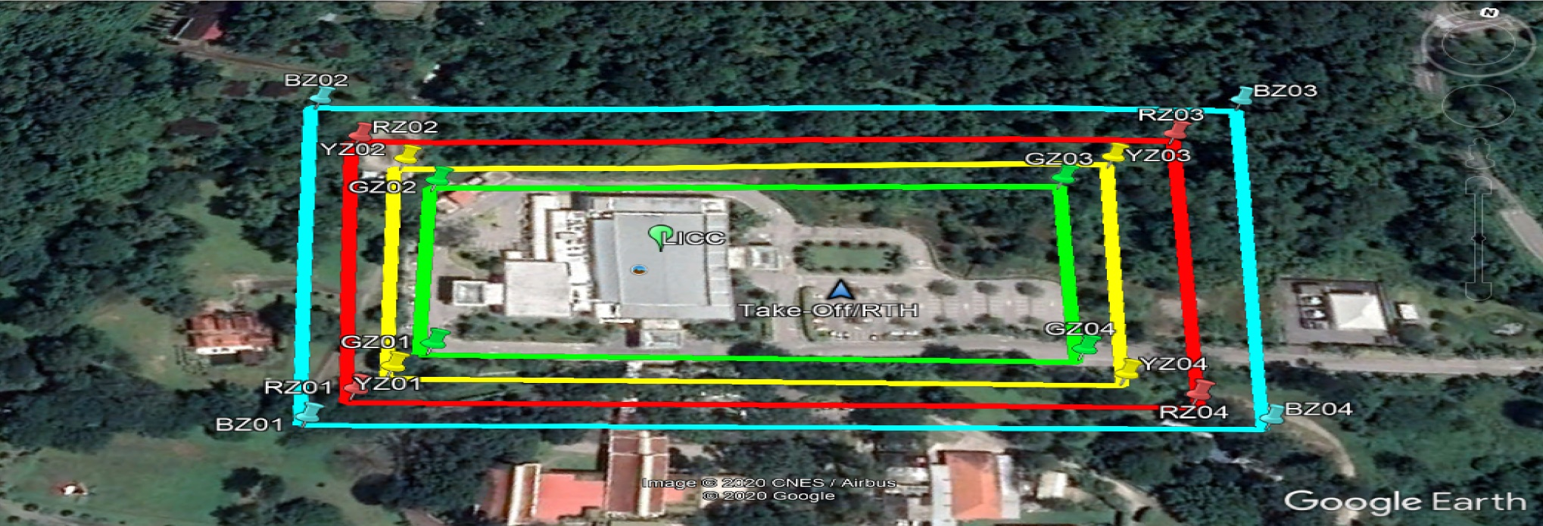
Zone | 1 | 2 | 3 | 4
Activity  (Green Zone) | 6°18'06.2"N 99°51'21.6"E | 6°18'06.6"N 99°51'23.7"E | 6°18'08.4"N 99°51'23.3"E | 6°18'08.2"N 99°51'21.2"E
Geo-fencing (Yellow Zone) | 6°18'06.5"N 99°51'20.9"E | 6°18'06.1"N 99°51'21.0"E | 6°18'06.5"N 99°51'22.5"E | 6°18'06.8"N 99°51'22.5"E
Risk  (Red Zone) | 6°18'05.1"N 99°51'20.1"E | 6°18'05.9"N 99°51'25.6"E | 6°18'09.7"N 99°51'24.7"E | 6°18'09.3"N 99°51'20.8"E
Boundary  (Blue Zone) | 6°18'06.3"N 99°51'18.4"E | 6°18'04.9"N 99°51'18.8"E | 6°18'05.3"N 99°51'20.0"E | 6°18'06.7"N 99°51'19.7"E

KMZ File Structure
The activity area map drawn on map application (e.g.: Google Earth) shall be saved in KMZ format using folder structure as shown in the picture below: -
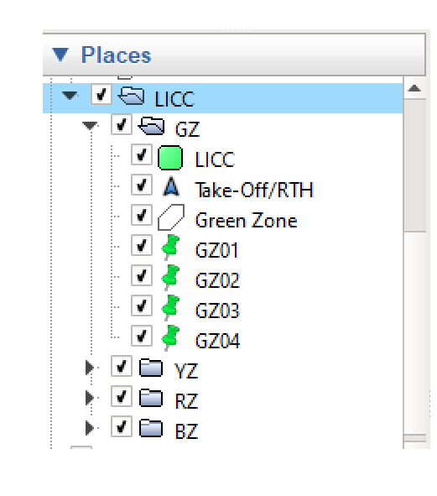
GZ – Green Zone
YZ – Yellow Zone
RZ – Red Zone
BZ – Blue Zone

PART B – Flight Mission (If Applicable)
The Accountable Manager shall submit the flight mission (screenshot) if UAS activity utilizing automated flight assistance for its navigation and operation.
The flight mission details shall include: -
No | Flight Mission | Description
1 | Flight Mission Planner Application Name
2 | Flight Mission Planner Platform (Android/iOS/Windows/Others)
3 | Mission Type (Survey, Inspection, etc)
4 | Total Distance Travel (km)
5 | Mission Speed (m/s)
6 | Total Mission Time Estimation (min)
7 | Mission Altitude (m)
8 | No. of Battery Use

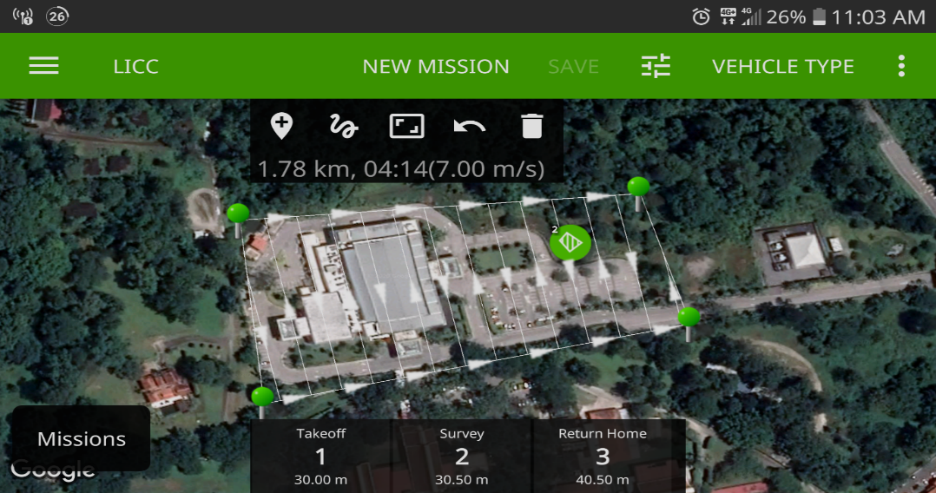
Automated Flight Mission Example
PART C - PERSONNEL LIST FOR THE UAS OPERATION
The Accountable Manager shall submit the details of all personnel involved for the UAS operation in form below:
No. | Name | IC Number | Mobile Number | Designation

DOCUMENT SUBMISSIONS CHECKLIST

No. | Documents | Yes | No | Remarks
1. | Accountable Manager Details:
 | a. Identification Card / Passport; and
 | b. Company Registration Certificate.
2. | SIRIM Approval / Certificate.
3. | MCMC Approval / Certificate¹ (if applicable).
4. | JUPEM Approval² (if required).
5. | Appointment Letter, undertaking the company for the said task.
6. | Pilot:
 | a. Competency Evidence³ (if applicable); and
 | b. Identification Card / Passport.
7. | .kml or .kmz file (Google Earth)
8. | UAS User Manual / Specifications Brochure.
9. | Evidence of Essential Services/MITI’s Approval Letter or equivalent (During MCO period/ period required by government)

*Application form and supporting documents needs to be submitted at least 14 days before the proposed activity date to drone.atf@caam.gov.my to avoid any delay.

¹ If UAS requires an Apparatus Assignment. (UAS using Class Assignment – 433 - 435 MHz, 2400 - 2500MHz, 5725 - 5875 MHz falls into Class Assignment and does not required an Apparatus Assignment).
² If UAS carries camera as payload.
³ Remote Pilot requires Private Pilot Licence and certification from OEM if UAS is 20 kilogrammes or more.

